

Semester Two Examination, 2022

Question/Answer booklet

MATHEMATICS SPECIALIST
UNITs 3&4

Section One:

Calculator-free

Your Name

Your Teacher’s Name

Time allowed for this section
Reading time before commencing work: five minutes
Working time: fifty minutes

Materials required/recommended for this section
To be provided by the supervisor
This Question/Answer booklet
Formula sheet

To be provided by the candidate
Standard items: pens (blue/black preferred), pencils (including coloured), sharpener, correction fluid/tape, eraser, ruler, highlighters

Special items: nil

Important note to candidates
No other items may be taken into the examination room. It is your responsibility to ensure that you do not have any unauthorised material. If you have any unauthorised material with you, hand it to the supervisor before reading any further.
Question | Mark | Max | Question | Mark | Max
1 |  |  | 5
2 |  |  | 6
3 |  |  | 7
4 |  |  | 8

Structure of this paper

Section | Number of questions available | Number of questions to be answered | Working time (minutes) | Marks available | Percentage of examination
Section One:  Calculator-free | 8 | 8 | 50 | 49 | 35
Section Two:  Calculator-assumed | 14 | 14 | 100 | 97 | 65
 |  |  |  | Total | 100

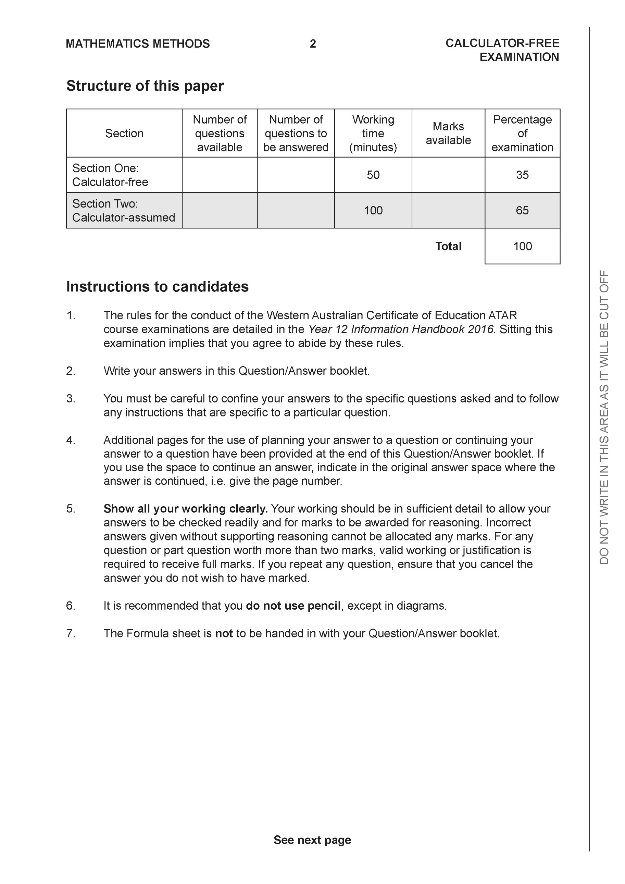

Section One: Calculator-free (49 Marks)

This section has 8 questions. Answer all questions. Write your answers in the spaces provided.

Spare pages are included at the end of this booklet. They can be used for planning your responses and/or as additional space if required to continue an answer.
● Planning: If you use the spare pages for planning, indicate this clearly at the top of the page.
● Continuing an answer: If you need to use the space to continue an answer, indicate in the original answer space where the answer is continued, i.e. give the page number. Fill in the number of the question that you are continuing to answer at the top of the page.

Working time: 50 minutes.

Question 1 (5 marks)
Consider the complex numbers and which are plotted below.

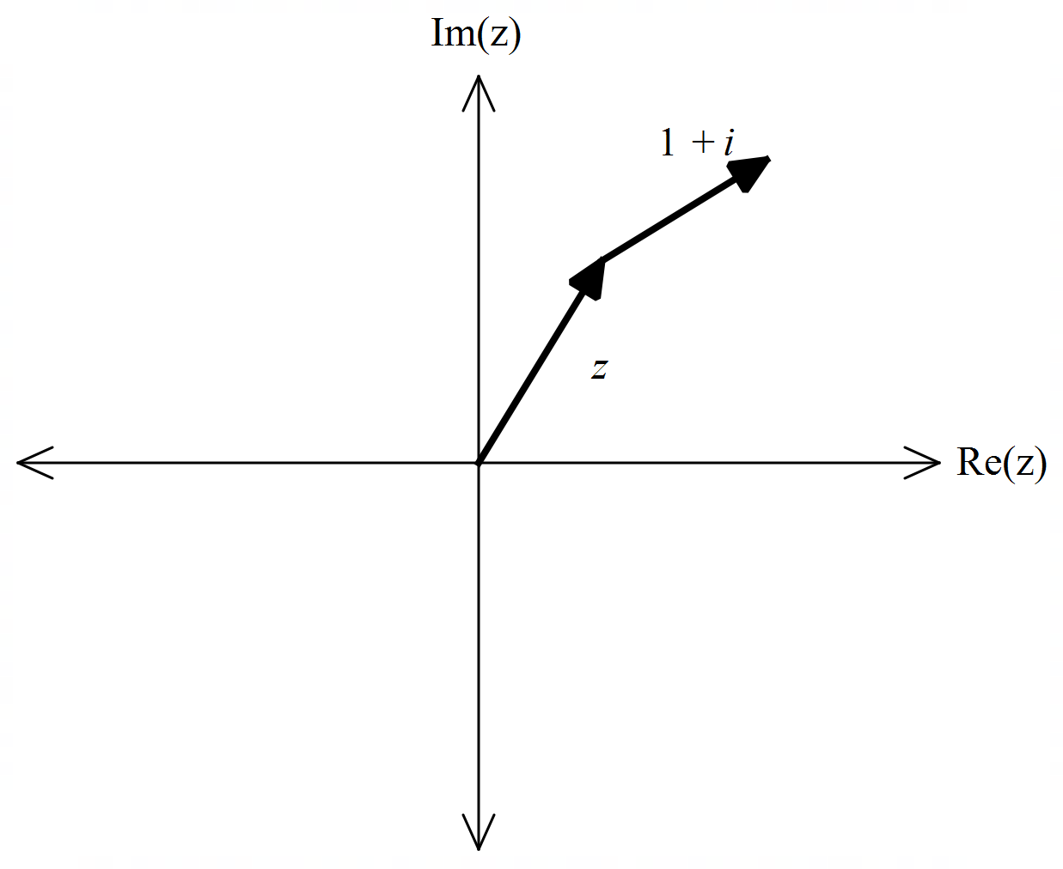

- Express in polar form. (1 mark)
Solution
Specific behaviours
states polar form

- Determine an exact expression for . (4 marks)
Solution
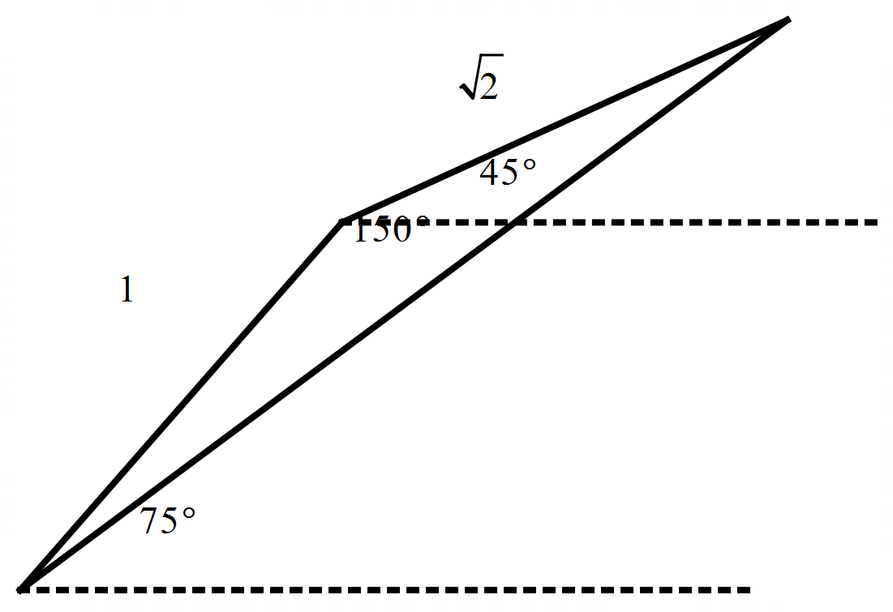

Specific behaviours
uses triangle with angles stated as above
uses cosine rule with correct lengths
evaluates cos 150
states exact answer as above without cosine

Question 2 (13 marks)

Consider the two functions as shown below.
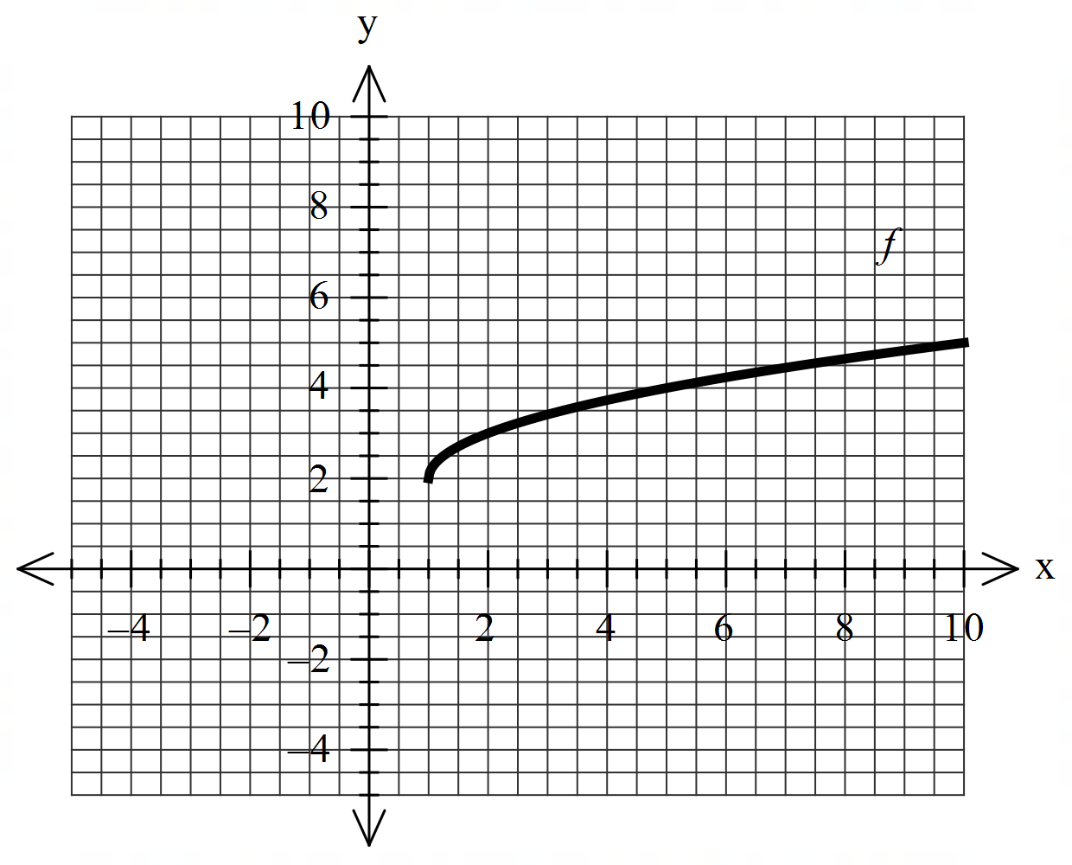 | 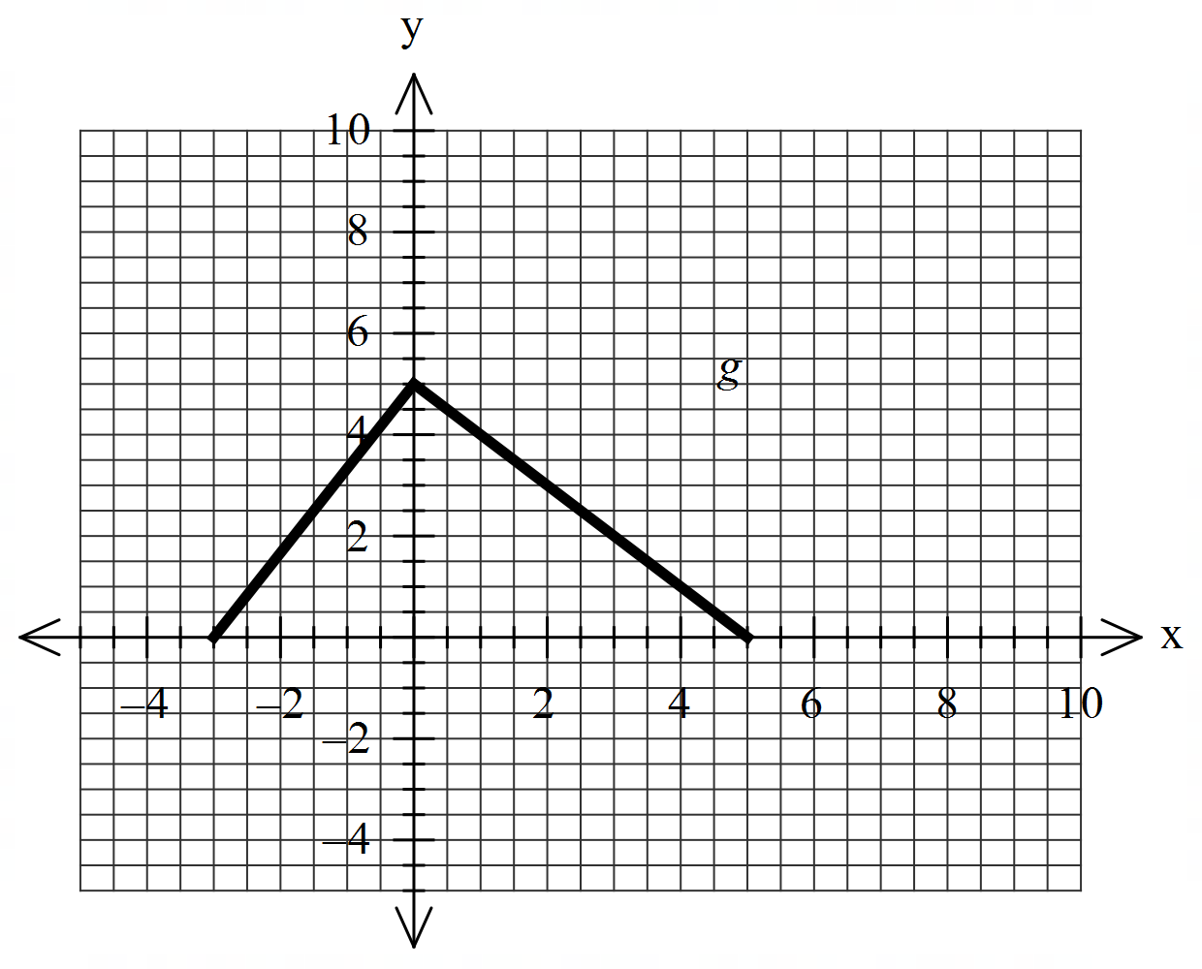
- Sketch the inverse of on the same set of axes. (2 marks)
Solution
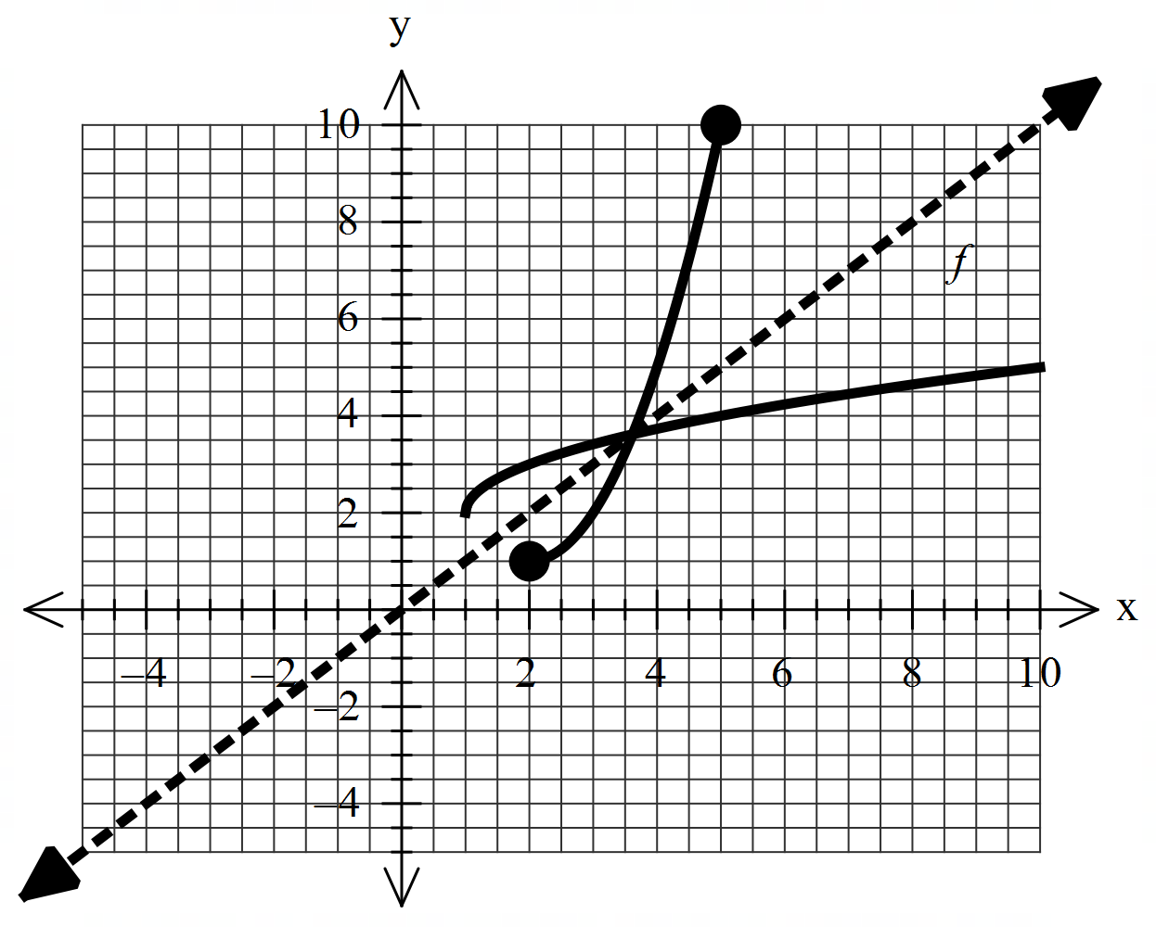

Specific behaviours
reflected in y=x
both endpoints correct

- Explain why does not have an inverse. (1 mark)

Solution
Many to one function

Specific behaviours
states reason

The defining rule for is as follows
- Determine the rule for and state its domain. (3 marks)

Solution
Specific behaviours
swaps variables or solves for x
states inverse rule
states domain

- Determine . (2 marks)
Solution
Specific behaviours
uses g(0)
states final result

- Does exist for all values of the natural domain of ? Explain. (2 marks)

Solution
Specific behaviours
states relevant domain and range
states no with a reason

- Determine the domain and range of . Justify. (3 marks)

Solution
Specific behaviours
uses domain of f
states range of f
states range of gof

Question 3 (5 marks)
Using an appropriate substitution, determine the following integral .

Solution
Specific behaviours
defines a subs variable u
changes integral from dx to du
changes limits to u values
integrates expression
obtains a value for integral in terms of surds

Question 4 (5 marks)
Consider the function . Sketch the function on the axes below showing all asymptotes and major features.

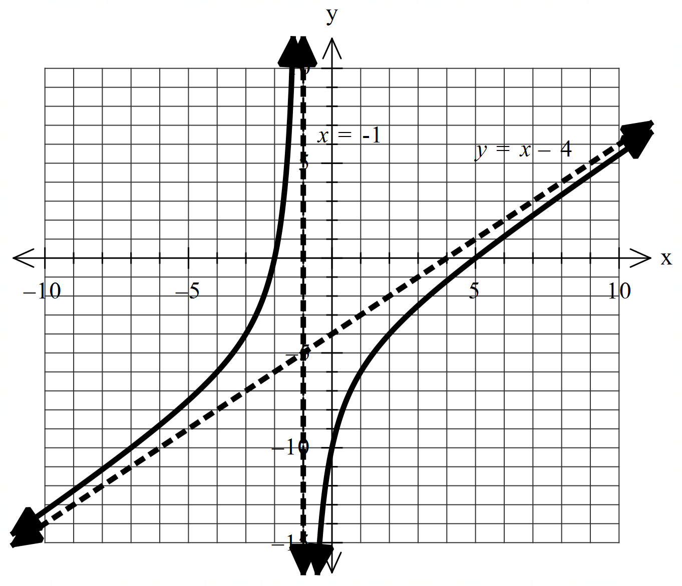

Solution
Specific behaviours
shows and labels vertical asymptote
shows and labels oblique asymptote ( accept y=x)
x intercepts correct
y intercept correct
shape is correct

Question 5 (6 marks)
- Given that , determine the values of the constants . (3 marks)

Solution
Specific behaviours
sets up quadratic equation with three constants
solves for a
solves for b & c

- Hence determine and express answer as one log term. (3 marks)

Solution
Specific behaviours
integrates all terms
subs limits and subtracts
expresses as one log term

Question 6 (5 marks)
Consider the polynomial with .
- Determine a quadratic factor of . (2 marks)

Solution
Specific behaviours
uses conjugate
states quadratic factor

- Hence solve the equation (3 marks)
Solution
Specific behaviours
solves for second quadratic factor
uses quadratic equation
states all four roots

Question 7 (5 marks)
By using and De Moivre’s theorem, determine exact values for .

Solution
Specific behaviours
sets up equation to find cartesian roots
determines polar square roots
solves for a & b
equates real and imaginary parts of both forms of roots
states exact surd expressions for cosine and sine

Question 8 (5 marks)
Determine the integral showing full working.
Solution
Specific behaviours
takes out one sin expression
uses Pythagorean to convert rest to cos functions
expands brackets into 3 terms
integrates all terms by adding one to cosine power
determines all correct factors (no need for plus constant)

Working out space

